Programming Fundamental

Semester Project

Game of Chess

**Phase 1(20% credit is of this phase) :**

Discuss MAIN FLOW

* Memory Requirement
* Initializing the Board
* Displaying the Board in the form of a grid (8x8 grid)
* Taking input coordinates by the player
* BASIC Validating (whether the selected piece is the piece of the player) and where the player placed is a legal destination
  + (regardless of checking the move of the piece) i.e. either it is a space character or opponent piece.
* Updating memory
* Turn changing

Write the main flow of your game (game-loop). Making sure that the game is turned by turn rotated between two players and in case of illegal move (by touching other players piece or holding an illegal piece(space or opponent piece) the turn shouldn't be changed and the flow is repeated.

**Phase 2(30% credit is of this phase) :**

The tasks were: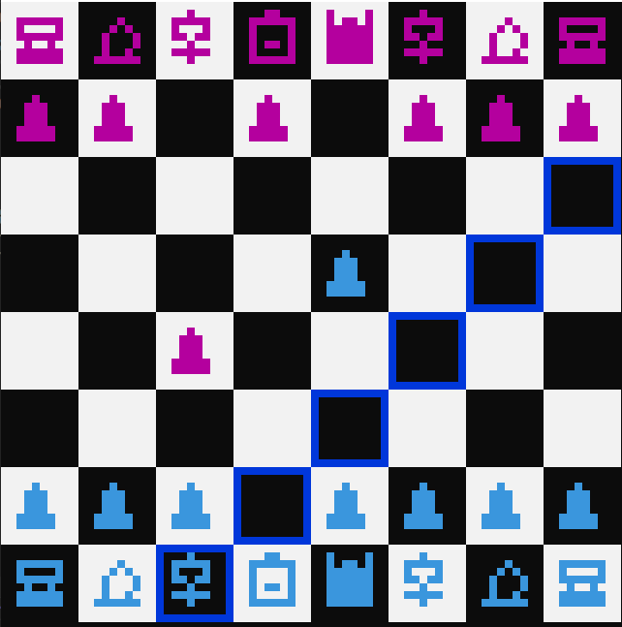

1. IsLegalMove:

* isLegal pawn
* isLegal King
* isLegal Queen
* isLegal Bishop
* isLegalRook
* isLegalKnight
* Helper Functions:
* isHorizontalMove
* isVerticalMove
* isDigonalMainMove
* isDigonalSecMove

1. Mouse Click implementation

### Phase 3(50% credit is of this phase) :

The tasks were: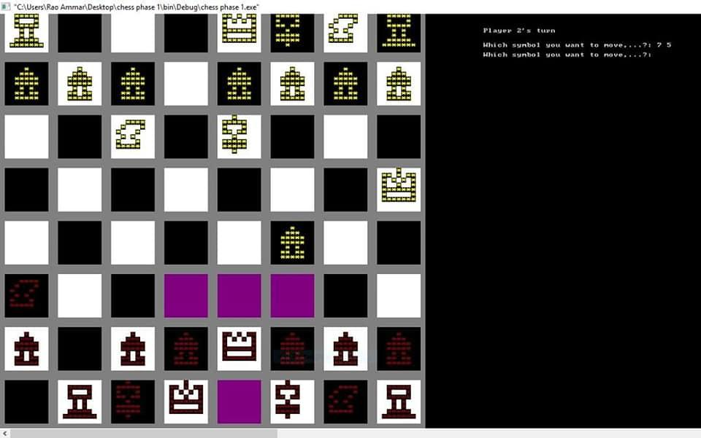

1. Highlight
2. Unhighlight
3. Check
4. Selfcheck
5. Checkmate
6. stalemate
7. Undo and Redo
8. Pawn Promotion
9. Save and Load game
10. Castling
11. replay

**Bonus(extra 20% credit ) :**

* Graphics